How to Submit a Continuing Review (aka, annual renewal) in KP

Log into KP with your CSU EID and password. Then click on the protocol you need to renew. When that protocol comes up on the screen, look on the right-side menu and choose ‘Renew’ OR if changes are needed to your study ‘Renew & Amend’.
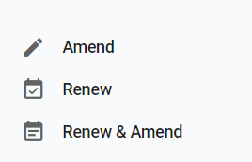

Once you do that, you can fill out the Continuing Review (CR) Form by answering all the questions.
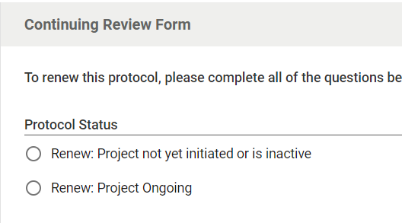

And the animal usage table:
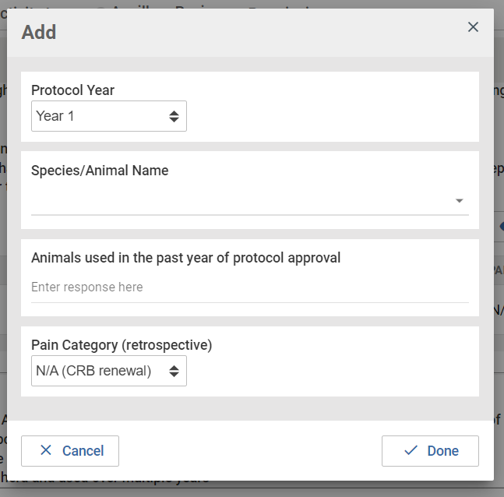
If you selected the ‘Renew & Amend’ form you will be required to complete the Amendment Request box. Please ensure to appropriately update your study with this information as well.
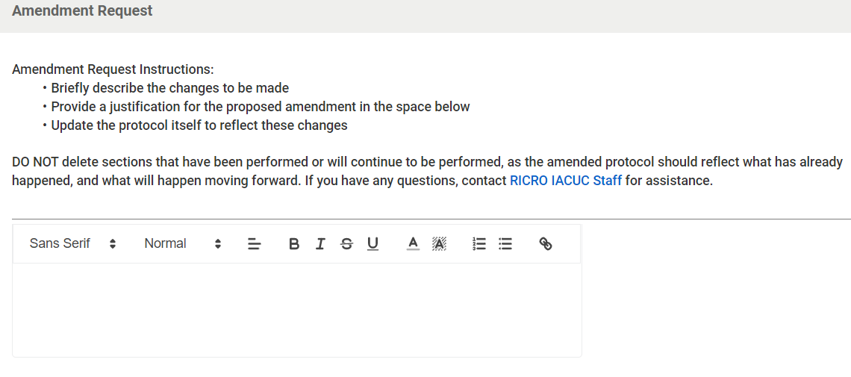

Then click “Submit” on the right-side menu—you should also get an email from KP that it was submitted.
