Effort Coordinator (aka ‘Grant Manager’) Override Instructions

Purpose: These instructions should be used for making project (53 account)-based Effort Coordinator reassignments in ecrt. For making or changing assignments based on Principal Investigator (PI), refer to the ‘Manage Assignments’ instructions.

NOTES:
- Terminology has changed in ecrt/ECC over time, and the previous label of Grant Manager has been changed to Effort Coordinator in several places. There is also one location where the assigned Effort Coordinator is called the ‘Account Manager’.
  - In ecrt, all three terms are synonymous and refer to the person who receives the email notifications for pre-review and the cc: emails during certification period, and has their assigned projects on the Home Page ‘Assigned Accounts’ tab.

- The Effort Coordinator role in ecrt is separately maintained from the Fiscal Officer and Account Manager roles in KFS.

By default, a department’s Primary Effort Coordinator (PEC) is assigned as the Effort Coordinator (aka Grant Manager) for all projects. If another person needs to manage a project within the department, they need to be assigned as the Grant Manager (Secondary Effort Coordinator). This means you are overriding the current Grant Manager (i.e. the PEC).
The Grant Manager (Secondary Effort Coordinator) will receive an automated e-mail from ecrt assigning them the task to Pre Review the project statements for which they were assigned. Assigned accounts and related Payroll Tasks will display on the Grant Manager’s Home Page:
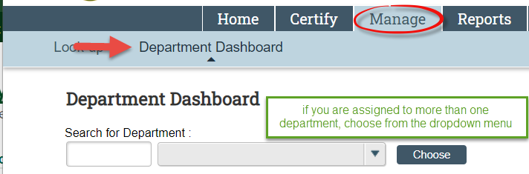
You can update the Grant Manager (Secondary Effort Coordinator) by navigating to the Department Dashboard.

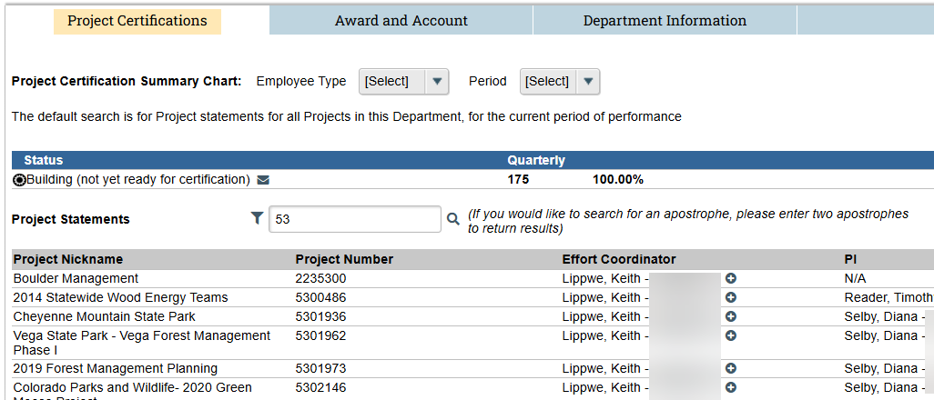
The Project Certifications tab will be displayed by default.
To assign an Effort Coordinator Override, the user selects the plus () icon next to the current Effort Coordinator’s name.
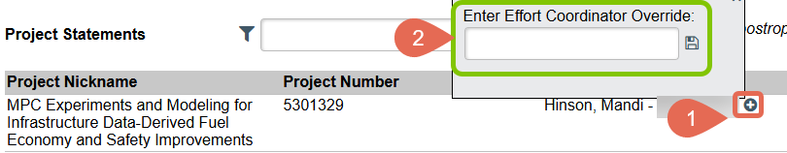
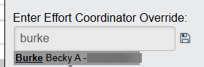
This brings up a search field where the user can type in the name of another person to assign as a Grant Manager (Secondary Effort Coordinator) for that specific project.
- Click the correct name from the list of suggestions, then click the ‘save’ icon.
When an Effort Coordinator) Override has been assigned, a red minus () will be displayed next to the plus icon.

Clicking on the icon removes the override and returns the Effort Coordinator assignment to the department’s primary effort coordinator or PI name-assigned coordinator.
Note: This icon only appears when an Effort Coordinator Override has been assigned.

You can also add a Grant Manager (Secondary Effort Coordinator) from the Account/Award Summary page:

