RESEARCH ADMINISTRATION AT CSU
Organizational models for research administration vary from institution to institution. How research administration is organized is influenced by a number of factors including institutional history, culture, and resources.
At CSU, research administration is a shared responsibility across many units including departments, centers, schools, colleges, and central offices. Because roles and responsibilities are distributed broadly, successful research administration relies on partnerships and strong communications between functioning units and clear understanding of the roles and responsibilities inherent in the various functions.
Roles, Responsibilities, and Relationships
Principal Investigator (aka, PI, faculty, investigator, project director): Individual judged by the applicant/awarding organization as having the level of authority and responsibility to direct the sponsored project or program. Responsible for ensuring expenditures are in accordance with sponsor and University regulations, policies, and procedures and responsible for regulatory compliance, effort reporting, and technical reporting back to the sponsor.
Unit administrators (aka, research administrator, financial & research manager, research project coordinator): Unit administrators play a critical role in the success of the research operation. Unit administrators may assist faculty in both pre- and post-award services. Unit administrators work with PIs and division business managers to support PIs in the development of proposals and related financial narratives/budgets and aid PIs with project management including appropriate spending and ongoing review of project costs.
Sponsored Programs: Authorizes and submits proposals on behalf of the University and negotiates/receives awards; creates accounts per award terms and conditions; issues and monitors subawards; provides management and oversight for proposal and awards; provides financial reporting back to the sponsor.
Related Offices (OVPR, RICRO, Secure & Global Research, Human Resources, Business & Financial Services, Procurement, Internal Audit, legal, etc.): PIs are responsible for complying with these oversight areas. Unit administrators provide assistance and sponsored programs confirm approvals.
ROLES & RESPON MATRIX HERE
Office for the Vice President for Research
At CSU, central research administrative functions are organized under the Office of the Vice President for Research (OVPR). The OVPR encompasses typical pre- and post-award services, along with other research administration functions and initiatives such as research development, research analytics, industry partnerships, export control, classified research, biosafety, and regulatory compliance.
OVPR ORG CHART

Those interested in engaging in sponsored programs should be keenly aware of four primary offices under the OVPR: the Research Acceleration Office, the Office of Sponsored Programs, the Research Integrity & Compliance Review Office, and Secure & Global Research.
Research Acceleration Office
The Research Acceleration Office (RAO) provides research development services to the CSU research community through strategic research initiatives, support for interdisciplinary programs, assistance with complex proposal development, and oversight of the limited submission program.
RAO provides individualized services for researchers including:
- assistance with early career planning and development
- identification of external resources to support research activities (SPIN funding database)
- grant writing workshops utilizing peer review (e.g. NSF CAREER Program; Early Career Investigator Workshops)
- internal funding programs (e.g., Pre-Catalyst for Innovative Partnerships)
- grant writing/editing services
- coordination of complex, multidisciplinary proposals
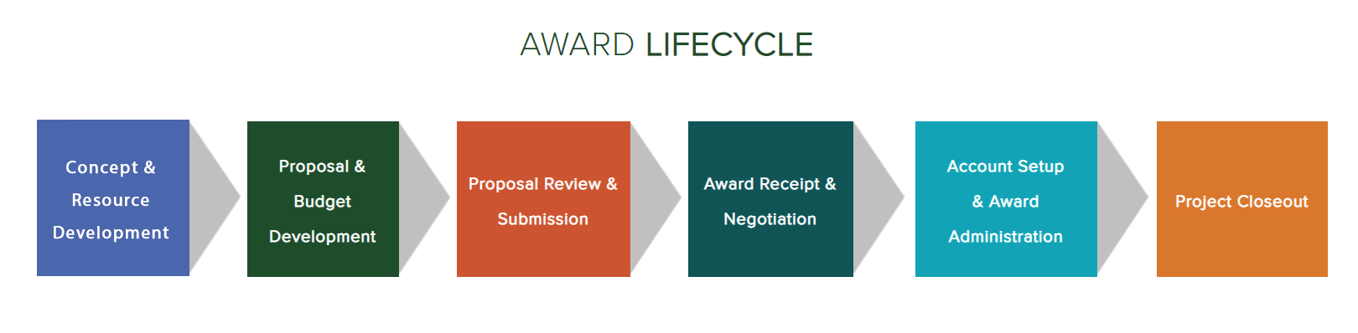
Considered the pre- pre-award office, RAO is the first stop in the lifecycle of research/proposal development for faculty and staff wanting to engage in sponsored programs.
Office of Sponsored Programs
The Office of Sponsored Programs (OSP) supports the CSU community in pursuit and conduct of externally funded projects. Pre- and post-award lifecycle services include:
- proposal and budget development
- proposal review and submission
- award receipt and negotiation
- account setup and award administration
- financial reporting and project closeout
Additionally, OSP assists with:
- subaward administration
- effort reporting
- review of non-financial agreements (e.g., Material Transfer Agreements and Non-Disclosure Agreements)
- training on research administration
The OSP is organized into pre-award teams that serve various colleges and units. OSP pre-award administrators work closely with unit administrators, business officers, and investigators to prepare and submit proposals for extramural funding. In the OSP, pre-award includes assistance with proposal and budget development, proposal review, signature authority, and submission, and award receipt and negotiation.
Post-award services provide account set up and assistance with award administration and project closeout. OSP post-award staff assignments are based on sponsors. Post-award works closely with unit administrators and PIs to ensure grant funds are spent within the project periods and sponsor guidelines, and handles invoicing and financial reporting for sponsored program accounts.
In addition to pre- and post-award services, OSP has a Subaward team that consists of a Subaward Administrator and a Subrecipient Risk Analyst & Invoicing Administrator. The Subaward team reviews, issues, and monitors all subawards from CSU to recipient institutions or organizations.
OSP ORG CHART
At CSU, sponsored program administration is a responsibility that is shared between the Principal Investigators (PIs), department/unit administrative offices, sponsored programs, and related offices such as Research Integrity & Compliance, Procurement, and Business & Finance.
Because of the number of individuals and units involved with a given sponsored project, everyone must have clear understanding of their roles and responsibilities and must be in communication in order to effectively and successfully manage sponsor funds.
Research Integrity & Compliance Review Office
The Research Integrity & Compliance Review Office (RICRO) provides assistance to researchers, staff, and oversight committees in the following areas:
- protection of human participants in research
- protection of the use of animals in research, teaching, and demonstration
- oversight of activities involving potentially biologically hazardous materials
- responsible conduct of research
- conflict of interest and conflict of commitment
- quality assurance standards in research and manufacturing activities
The intersection of research administration and research compliance occurs when a sponsoring agency has a requirement related to one of the above areas. Regulations require institutions to provide appropriate support for these activities and their related education and oversight programs.
Secure & Global Research
Secure & Global Research (SGR) aids investigators in navigating federal regulations related to export controls, controlled unclassified information, classified research and common access cards.
Engage SGR early if research, whether externally funded or not, may involve controlled or classified information or may involve technologies being exported to other countries or are at risk of being shared with denied parties.
Summary
Administering the CSU research enterprise is a complex endeavor that involves individuals in multiple offices across campus. Each office, each investigator, and each sponsor has their own interests and requirements, all of which must be addressed. In order to ensure the research enterprise remains vibrant and sustainable, it is imperative that everyone understands her or his role in the process and that we work together collaboratively.

