How To Request Services
All requests should originate from the LAR website: https://www.research.colostate.edu/lar/
- Under the “LAR Services” tab, click on “Work Orders/Animal Transfers/Cage Card Requests” and log in with your CSU eID/password

Work Orders for Tech Services/General Services:
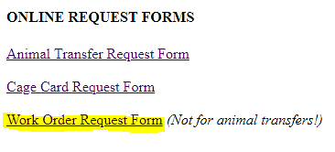
- From the LAR Forms main page, click on the link for Work Order Request Form

- Begin to fill out the work order request. The WO category should best match the service you are in need of.
  - Select “Vet Tech Services” for:
    - Euthanasia (sacs)
    - Technical services supplies (such as anesthesia machines or equipment, isoflurane refills, surgical supplies, medications, or controlled substances)
    - To schedule use of the Surgery or Necropsy rooms
    - Any procedure that you would like LAR vet staff to complete
    - **Do NOT enter in animal transfer requests through this form. Please use the designated “Animal Transfer Request” form**

  - Select “Supply Order” for:
    - Scheduling the movement of caging/medical supplies from one building location to another building location

  - Select “Facility/Animal Care Concerns” for:
    - Reporting facility maintenance issues, i.e. chipped paint, broken equipment in the room, removal of screws/nails in walls
    - Reporting Animal Care Concerns, i.e. broken caging, room cleanliness

  - Select “General” for:
    - Any miscellaneous request that does not fall into the other categories

- The “Date Service Required” must be set for two business days in the future.
  - LAR IS NOT ABLE TO ACCOMMODATE SAME DAY REQUESTS
  - Submitting requests at least 2 business days in advance will greatly help LAR staff to meet your needs in a timely manner.
- Continue to fill out the white boxes in the form. If you do not know the value that should be in that box, enter in “N/A”.
- In the Requester Comments section, relay any pertinent information about your request (e.g. cage card numbers, amounts of supplied needed, time frames, special instructions).

