Procedures to add/delete, amend, or change protocol account numbers

Account Number Basics

- Account Numbers are managed by protocol. Make sure your account has been added to the appropriate protocol number(s) before proceeding with creating animal requisitions, changing an account, transfers, etc.
- Investigators or other Power Users are responsible for maintaining and updating account numbers. This action can be performed by associates listed on protocols, including the role of Department Financial Administrator (DFA).
- The PI is responsible for notifying the RICRO office to add/change funding on their approved IACUC protocol, especially if the new account is PHS or NSF funded.

Adding an Account
Account numbers must be added to each Protocol that will use that funding source. The Expiration Date and Funding Source field can be changed after an account has been added. All other information is unmodifiable.

In eAnimal Ordering (eAO) go to INVESTIGATOR or DFA > LIST OF PROTOCOLS. Under column header PROTOCOL ID click on protocol to update.
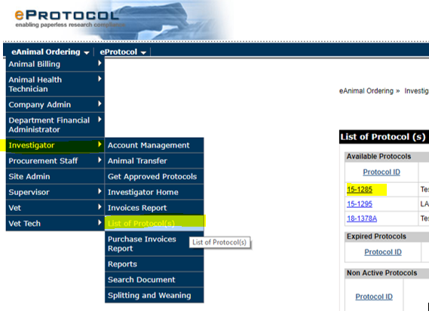

The protocol details will load in a new window.

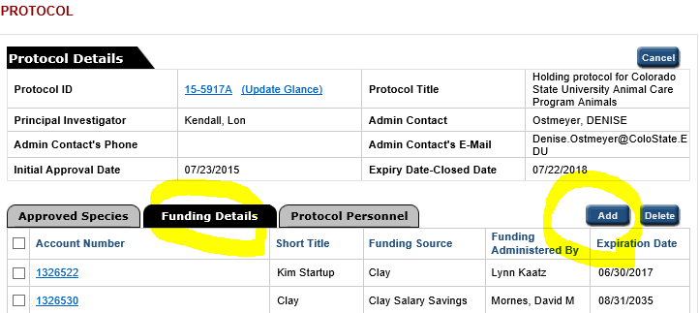

Click FUNDING DETAILS and then Click ADD.

The ACCOUNT DETAILS box will appear (sometimes this box is hidden behind other screens).
Add account details.
- An Account Number MUST be a 7-digit CSU account number active in KFS.
- No special characters or spaces allowed.
- To add a SUB-ACCOUNT, you can add this to the end of the account number.
EXAMPLE: 5312345MOU
The underline represents the subaccount (no dashes or spaces allowed).
- Expiration date generally coincides with the Account Expiration Date in Kuali.
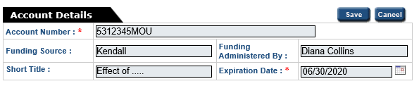

Changing an Account Expiration Date or Funding Source field
- Go to FUNDING DETAILS. See above instructions to get here.
- Click on the Account Number you want to change.
- The Account Details box will appear and you can update these fields here.
- Click SAVE.

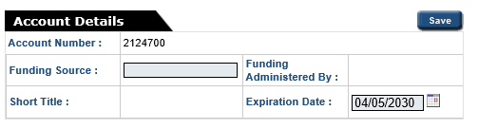

Deleting an Account
- Go to FUNDING DETAILS. See above instructions to get here.
- Select the check box next to the account that you wish to delete.
- Click DELETE button on top right side of account list.
- It is only possible to delete an account if there are no cages that are assigned to the account. To check what cages may be assigned to an account and to modify which account per diems are charged to, see the “Changing Account Number” Section below.

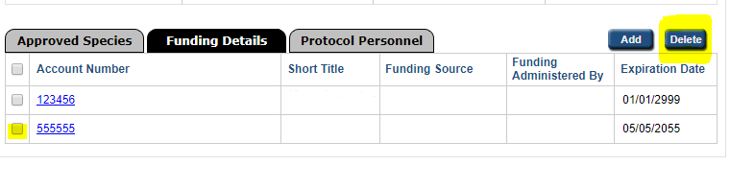

Changing Account Number - effective 1st day of current billing cycle
- THIS ACTION CREATES A CHANGE USING AN EFFECTIVE DATE OF THE FIRST DAY OF THE CURRENT BILLING CYCLE (21st of month).
- If you need to make adjustments to a previous billing cycle, to change an account in the middle of a billing cycle, please contact your department fiscal officer to create a GEC in Kuali.

Go to DFA or INVESTIGATOR > ACCOUNT MANAGEMENT
You have 2 options here! You can change the account for the Per diem and Purchase for animal orders.
If you want to change both you will need to repeat these steps and select the other option.

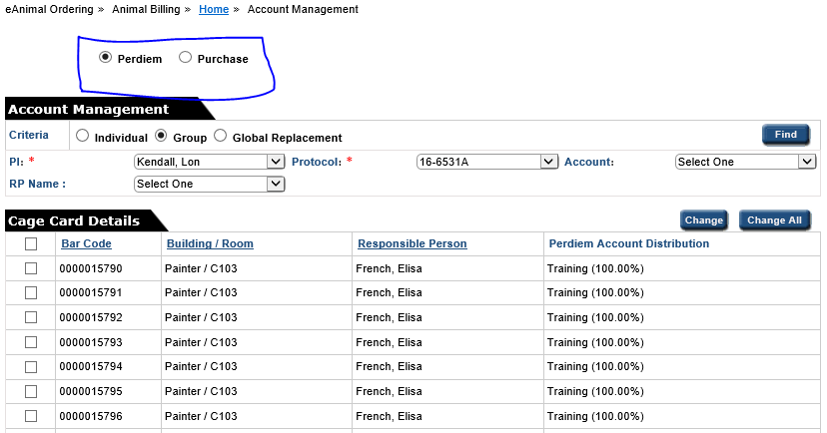

- If changing (1) cage card you do not need to change the CRITERIA
  - If changing more than one cage card select GROUP.
    - Note: We do not use GLOBAL REPLACEMENT so you will never select this option.
- Select the PI and Protocol from the dropdown menus. You can also narrow your search by Account. If selected, this will only return the cage cards associated with that account.
- Click FIND. A list of all the cage cards associated with that protocol will appear.
- Check the box to the left of the bar code number(s) for specific cage cards or select all.
- Click CHANGE or CHANGE ALL

A pop-up window will appear with the Account Details assigned to this protocol. (If your Account is not listed here, you will need to add it to the protocol. See “Adding an Account”.)
- Check the box(es) for the account you wish to transfer the cages to.
- Type in percentage(s). The total must equal 100.
- Click SAVE

