Test Description: NanoString nCounter® Analysis System. This system uses molecular "barcodes" and single-molecule imaging to profile up to 800 mRNAs, microRNAs, or DNA targets simultaneously with high sensitivity and precision, without any reverse transcription or amplification.

Species: all- researcher should work with nanostring to provide off the shelf or custom gene panels https://nanostring.com/products/ncounter-assays-panels/

Samples: For RNA samples we recommend at least 100ng of RNA samples, though samples >20ng can be run. Recommended spectrophotometer 260/280 ratio is 1.7-2.0. Nanostring recommends that 50% of the samples be greater than 200 nucleotides- modifying input RNA to meet these criteria. Sample fragmentation can be assessed via tapestation analysis for an additional charge. Below is a generalized chart of needed sample input for a variety of nanostring assays.
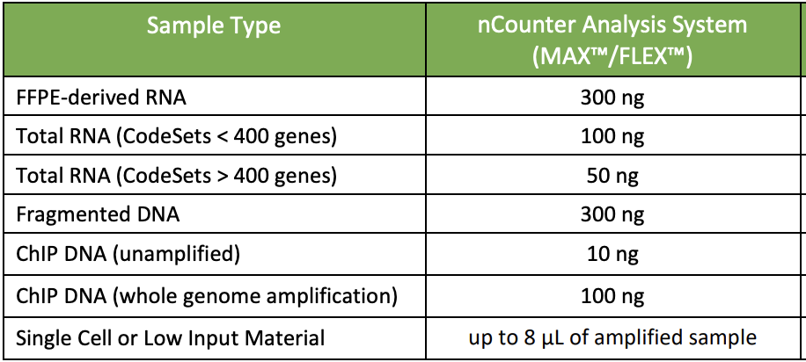

Expected results:

Gene Expression
Limit of Detection:
• 0.5fM spike-in control (~1 copy per cell); 90% of the time
Fold-change Sensitivity:
• >1.5 fold (>5 copies per cell)
• >2 fold change (>1 copy per cell)
miRNA Assay
Limit of Detection:
• ≤ 0.5fM (~10 copies per cell)
Fold-change Sensitivity:
• > 2 fold change
Copy Number Variation
Reproducibility:
• 99%
Number of Copies Detected:
• 0-4, multiallelic
miRGE Assays
Limits of Detection:
• For miRNA: >2.5 copies per cell copy per cell
• For mRNA: 1 copy per cell
Fold-change Sensitivity:
• >2 fold change

Turnaround Time: Depends on assay

Please contact the EPF for a submission form and sample handling instructions

