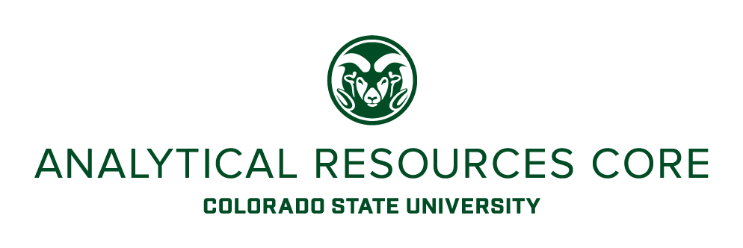

Undergraduate Internship Program
Analytical Resources Core

The Analytical Resources Core (ARC) is looking for Chemistry undergraduate students to participate in its Undergraduate Internship Program (UIP) (https://www.research.colostate.edu/arc/uip/) through the Chemistry’s CHEM 487 for-credit Internship course. The UIP program, which was established as a collaboration between the ARC and instrument vendors, provides undergraduate students from Science, Technology, Engineering, and Mathematics (STEM) hands-on training and experience in the use, operation and maintenance of state-of-the art research instrumentation in the facilities. Selected CHEM 487 students would be tasked with assisting in analytical services and general laboratory tasks in the different laboratories. Primary responsibilities will include assisting in sample prep, routine analyses and preventative maintenance on GC and LC mass spectrometers, but duties may extend to other lab areas such as NMR, XRD, thermal analyses, spectroscopy and electron microscopy. Other duties will include administrative tasks, assistance with instrument maintenance (e.g. cryogen fills, vacuum pump maintenance) and repairs, and general laboratory tasks (inventory, solvent prep, hazardous waste handling, etc.). The position will offer the candidate valuable hands-on experience on a variety of state-of-the-art analytical equipment used in the chemical, materials and life sciences.

The successful candidate must be enrolled in CHEM 487, and have completed course work in organic and analytical chemistry. Basic knowledge of analytical instrumentation is required, in particular MS. The ideal candidate would intern as part of CHEM 487 for one semester, and, if successful, will have the chance to be hired into a paid internship in the ARC’s UIP program with opportunities to continue until graduation.

For more information about CHEM 487 Internship credit, contact Prof. Carlos Olivo (970-491-0722; colivo@colostate.edu).

For more information about the ARC UIP program, contact the ARC Chair, Dr. Karolien Denef (karolien.denef@colostate.edu; 970-556-4846).

Additional information about the ARC can be found at https://www.research.colostate.edu/arc/.

